**Why is Breakfast Important?**

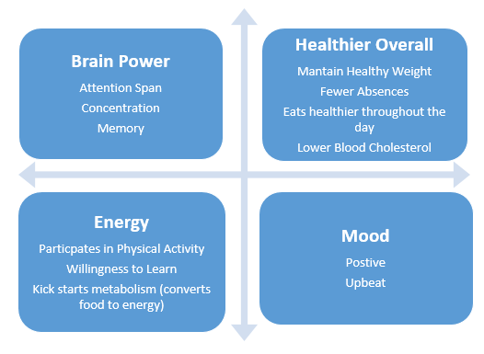

By: Ashley Hynes



**Breakfast Ideas:** Whole-Grain Breads Fruits Low-fat/Nonfat Dairy Eggs Nuts Whole-Grain Cereals

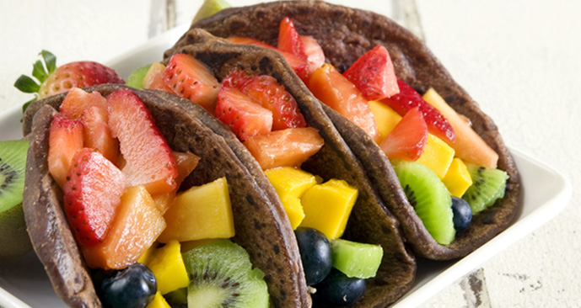

**Fruit Taco**

1. Cut up different fruit (bananas, kiwi, strawberries, etc)
2. Spread Peanut Butter (Soy-Nut Butter) on whole-wheat tortilla
3. Add fruit to tortilla
4. Fold tortilla into a taco

**Choosing Breakfast Foods…**

1. Rich in Whole-Grains
2. Rich in Fiber
3. Rich in Protein
4. Low in Added Sugar

**Benefits:**

1. **Brain Power**
2. **Healthier Overall**
3. **Energy**
4. **Mood**