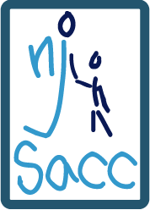
By: Ashley Hynes
Family Meals & Nutrition
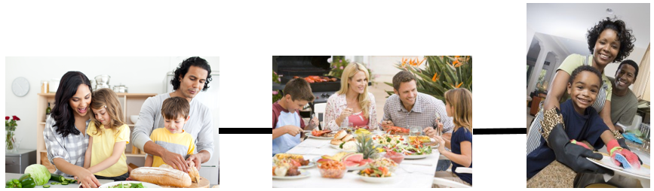
Cooking/Preparing
Cleaning
Eating

Benefits
Modeling Behaviors | Health & Nutrition | Social Skills
- Manners  - Values & Attitudes  - Good Nutrition Practices  - Structure  - Routines | - Lower BMI  - Lower risk for obesity  - Increased consumption of healthy foods (fruits and vegetables)  - Healthy Development | - Family Time/  Communication  - Discussion of nutrition-related topics  - Better relationships outside the family

**Attached is a Family Meal Planner so the children can help choose different meals.

